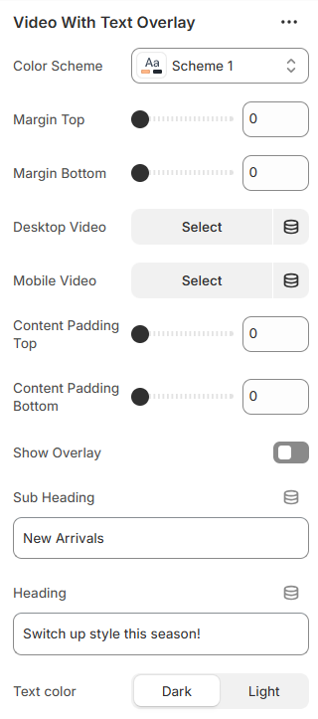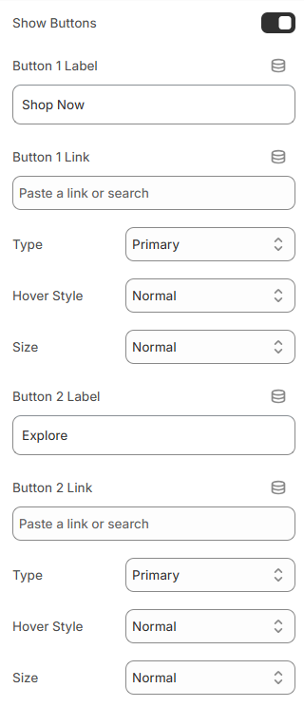

<section id="video-with-text-overlay">
<p class="subtitle">Mavro Theme – Media Sections</p>
<h2>Video With Text Overlay</h2>

<p>
This section allows you to display a responsive video banner with
overlay text and customizable action buttons.
</p>

<ol>
<li><b>Color Scheme</b> – Select the section color style.</li>
<li><b>Margin Top & Bottom</b> – Adjust spacing above and below the section.</li>
<li><b>Desktop Video</b> – Upload video for desktop devices.</li>
<li><b>Mobile Video</b> – Upload video for mobile devices.</li>
<li><b>Content Padding</b> – Control inner spacing (top & bottom).</li>
<li><b>Video Overlay</b> – Enable overlay with customizable color.</li>
<li><b>Sub Heading</b> – Add small introductory text.</li>
<li><b>Heading</b> – Add main banner title.</li>
<li><b>Text Color</b> – Choose light or dark text style.</li>
<li><b>Show Buttons</b> – Enable up to two action buttons.</li>
<li><b>Button Labels & Links</b> – Set button text and destination URL.</li>
<li><b>Button Style</b> – Choose primary, secondary, outline, or underline style.</li>
<li><b>Button Hover Animation</b> – Select slide animation direction.</li>
<li><b>Button Size</b> – Adjust button size or set full width.</li>
</ol>

<p>
These options allow you to create an engaging video hero section
with flexible text and call-to-action styling.
</p>
</section>

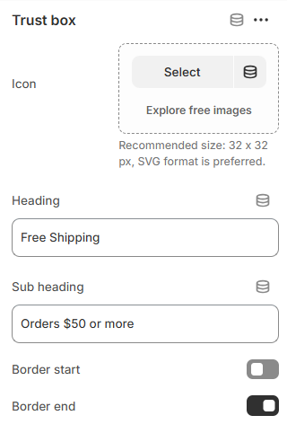

<section id="trust-bar">
<p class="subtitle">Mavro Theme – Promotional Sections</p>
<h2>Trust Bar</h2>

<p>
The Trust Bar allows you to highlight key store benefits such as
free shipping, secure payments, and customer support.
</p>

<ol>
<li><b>Color Scheme</b> – Select the section color style.</li>
<li><b>Margin Top & Bottom</b> – Adjust spacing above and below the section.</li>
<li><b>Border Top & Bottom</b> – Enable section borders.</li>
<li><b>Full Width</b> – Display the section in full-width layout.</li>
<li><b>Column View</b> – Show trust items in column layout.</li>
<li><b>Trust Box (Block)</b> – Add multiple trust items.</li>
<li><b>Icon</b> – Upload a 32×32px SVG icon (recommended).</li>
<li><b>Heading</b> – Add main trust message.</li>
<li><b>Sub Heading</b> – Add supporting description text.</li>
<li><b>Item Borders</b> – Enable left or right border per item.</li>
</ol>

<p>
These options help you showcase important store guarantees and
build customer trust effectively.
</p>
</section>

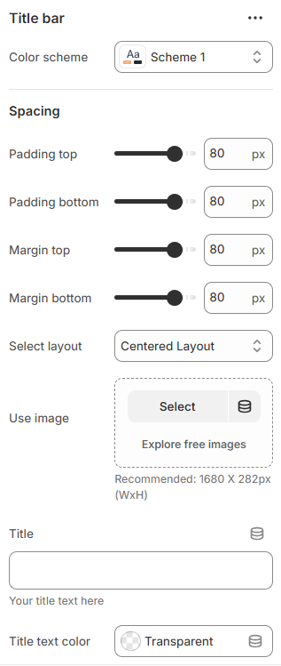
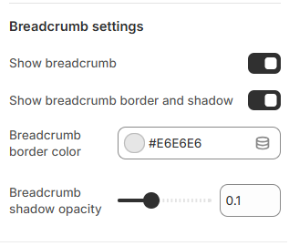

<section id="title-bar ">
<p class="subtitle">Mavro Theme – Page Header Sections</p>
<h2>Title Bar</h2>

<p>
The Title Bar section allows you to display page titles
with multiple layout styles, background images, and breadcrumb controls.
</p>

<ol>
<li><b>Color Scheme</b> – Select the section color style.</li>
<li><b>Layout Type</b> – Choose between Simple Centered or Advanced Image layout.</li>
<li><b>Layout 1</b> – Add background image and customize title color.</li>
<li><b>Layout 2</b> – Add title, subtitle, text colors, and image layout options.</li>
<li><b>Image Layout Type</b> – Select Half (50/50 split) or Full background style.</li>
<li><b>Overlay Opacity</b> – Adjust image overlay shadow (Full layout only).</li>
<li><b>Breadcrumb Settings</b> – Enable breadcrumb, border style, color, and shadow opacity.</li>
<li><b>Spacing</b> – Control padding and margin (top & bottom).</li>
</ol>

<p>
These options provide flexible page header designs with customizable
layouts, images, and breadcrumb styling.
</p>
</section>

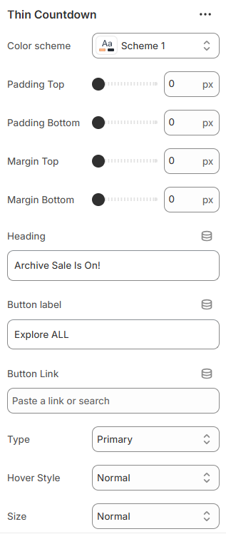

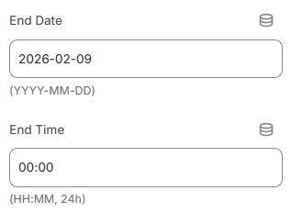

<section id="thin-countdown">
<p class="subtitle">Mavro Theme – Promotional Sections</p>
<h2>Thin Countdown</h2>

<p>
The Thin Countdown section displays a promotional message
with a countdown timer and optional call-to-action button.
</p>

<ol>
<li><b>Color Scheme</b> – Select the section color style.</li>
<li><b>Padding & Margin</b> – Adjust spacing (top & bottom).</li>
<li><b>Heading</b> – Add promotional text.</li>
<li><b>Button Label & Link</b> – Set button text and destination URL.</li>
<li><b>Button Style</b> – Choose primary, secondary, outline, or underline.</li>
<li><b>Button Hover Style</b> – Select animation direction.</li>
<li><b>Button Size</b> – Adjust size or set full width.</li>
<li><b>End Date & Time</b> – Set countdown expiration (YYYY-MM-DD & HH:MM).</li>
</ol>

<p>
These options allow you to create urgency-driven promotions
with customizable styling and layout control.
</p>
</section>

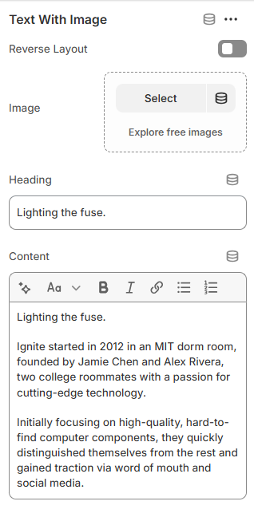

<section id="text-with-image">
<p class="subtitle">Mavro Theme – Content Sections</p>
<h2>Text With Image</h2>

<p>
The Text With Image section allows you to combine images
with descriptive content in a flexible layout.
</p>

<ol>
<li><b>Color Scheme</b> – Select the section color style.</li>
<li><b>Padding Top & Bottom</b> – Adjust vertical spacing.</li>
<li><b>Intro Block</b> – Add section title and subtext (limit: 1).</li>
<li><b>Text With Image Block</b> – Add up to 2 content cards.</li>
<li><b>Reverse Layout</b> – Swap image and text positions.</li>
<li><b>Image</b> – Upload featured image.</li>
<li><b>Heading</b> – Add card title.</li>
<li><b>Content</b> – Add rich text description.</li>
</ol>

<p>
These options help you create visually balanced content
sections with flexible image and text alignment.
</p>
</section>

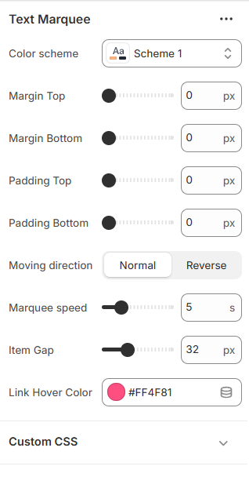

<section id="text-marquee">
<p class="subtitle">Mavro Theme – Promotional Sections</p>
<h2>Text Marquee</h2>

<p>
The Text Marquee section displays continuously scrolling text
for announcements, promotions, or highlighted messages.
</p>

<ol>
<li><b>Color Scheme</b> – Select the section color style.</li>
<li><b>Margin & Padding</b> – Adjust spacing (top & bottom).</li>
<li><b>Moving Direction</b> – Set scrolling direction (Normal or Reverse).</li>
<li><b>Marquee Speed</b> – Control scrolling speed (in seconds).</li>
<li><b>Item Gap</b> – Adjust spacing between marquee items.</li>
<li><b>Link Hover Color</b> – Customize hover color for links.</li>
<li><b>Marquee Items (Block)</b> – Add multiple scrolling text items.</li>
<li><b>Content</b> – Add rich text for each marquee item.</li>
</ol>

<p>
These options allow you to create dynamic scrolling announcements
with flexible styling and spacing control.
</p>
</section>

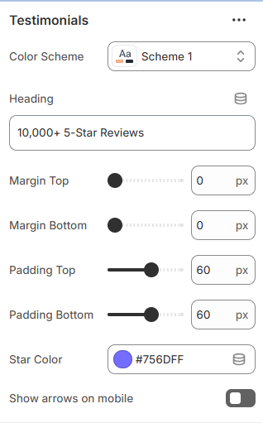

<section id="testimonials">
<p class="subtitle">Mavro Theme – Customer Reviews</p>
<h2>Testimonials</h2>

<p>
The Testimonials section showcases customer reviews, ratings, and feedback
to build trust and highlight your store’s credibility.
</p>

<ol>
<li><b>Color Scheme</b> – Select the section color style.</li>
<li><b>Heading</b> – Add a title for the testimonial section.</li>
<li><b>Padding & Margin</b> – Adjust spacing (top & bottom).</li>
<li><b>Star Color</b> – Customize rating star color.</li>
<li><b>Show Arrows on Mobile</b> – Enable navigation arrows for mobile devices.</li>
<li><b>Text Review Block</b> – Add reviews without images.</li>
<li><b>Image Review Block</b> – Add reviews with customer images.</li>
<li><b>Block Fields</b> – Include rating, title, description, author, and date.</li>
<li><b>Max Blocks</b> – Display up to 20 reviews.</li>
</ol>

<p>
These options help you display authentic customer feedback
in a visually appealing and trust-building way.
</p>
</section>

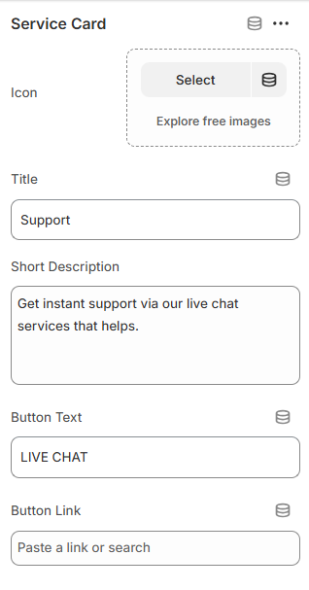
<section id="support">
<p class="subtitle">Mavro Theme – Customer Support</p>
<h2>Support Section</h2>

<p>
The Support section highlights your customer service options, providing
quick access to live chat, help guides, or other support channels.
</p>

<ol>
<li><b>Color Scheme</b> – Choose the section color style.</li>
<li><b>Padding</b> – Adjust top and bottom spacing.</li>
<li><b>Button Style</b> – Select button type, size, and hover animation.</li>
<li><b>Service Card Block</b> – Add up to 4 support cards with:</li>
<ul>
<li><b>Icon Image</b> – Upload an image or icon for each card.</li>
<li><b>Title</b> – Name of the service.</li>
<li><b>Short Description</b> – Brief explanation of the support option.</li>
<li><b>Button Text & Link</b> – Call-to-action for live chat or support page.</li>
</ul>
</ol>

<p>
This section allows you to showcase key support options prominently,
helping customers quickly find assistance.
</p>
</section>

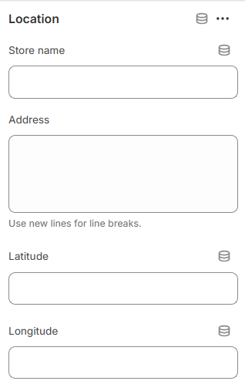
<section id="store-location">
<h2>Store Location</h2>

<p>
Highlight your physical store locations with optional map coordinates.
Each block can display a store name, full address, and latitude/longitude
for mapping.
</p>

<ol>
<li><b>Spacing</b> – Adjust padding and margin (top & bottom) for the section.</li>
<li><b>Location Block</b> – Add one or more stores with:</li>
<ul>
<li><b>Title</b> – Store name.</li>
<li><b>Address</b> – Full address (use line breaks for multiple lines).</li>
<li><b>Latitude & Longitude</b> – Optional coordinates for maps.</li>
</ul>
</ol>

<p>
This section helps customers easily find your physical store locations.
</p>
</section>

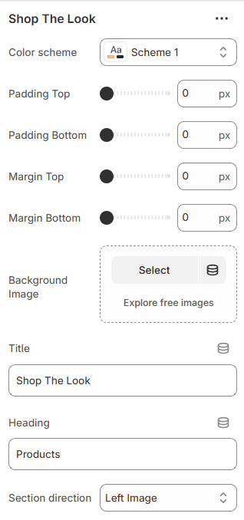

<section id="shop-the-look">
<h2>Shop the Look</h2>

<p>
This section allows you to showcase curated product combinations with a visually appealing layout.
You can overlay product hotspots on a background image to highlight individual products.
</p>

<h3>Settings Overview:</h3>
<ul>
<li><b>Color Scheme:</b> Choose a color scheme for text and accents.</li>
<li><b>Spacing:</b> Adjust padding and margin (top & bottom) for the section.</li>
<li><b>Background Image:</b> Upload a main image to display the curated look.</li>
<li><b>Section Title & Heading:</b> Add a title for the section and a heading above the product listings.</li>
<li><b>Section Direction:</b> Choose layout orientation: left-image (row) or right-image (row-reverse).</li>
</ul>

<h3>Product Hotspots:</h3>
<ul>
<li><b>Select Product:</b> Choose a product from your store to associate with a hotspot.</li>
<li><b>Position:</b> Set horizontal (left) and vertical (top) positions for the product hotspot on the image.</li>
<li><b>Dot Color:</b> Customize the color of the hotspot marker.</li>
</ul>

<p>
This section is perfect for visually engaging customers, showing them full outfits or curated looks, and linking each product directly to its product page for easy shopping.
</p>
</section>

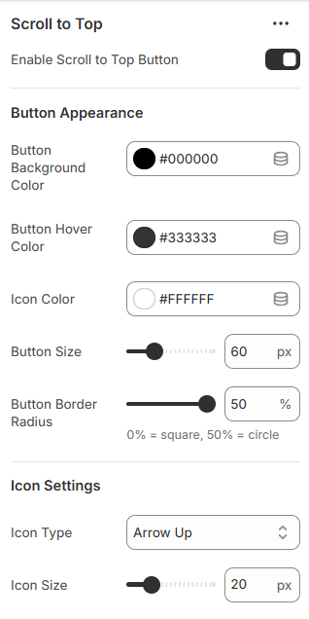
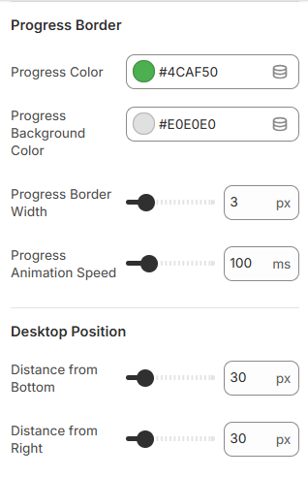
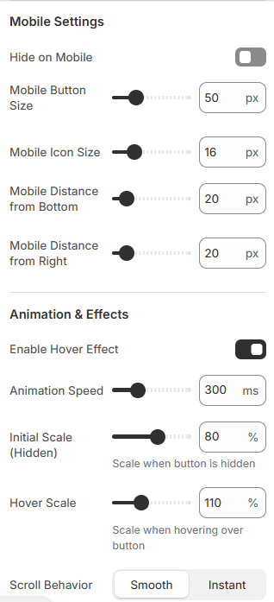
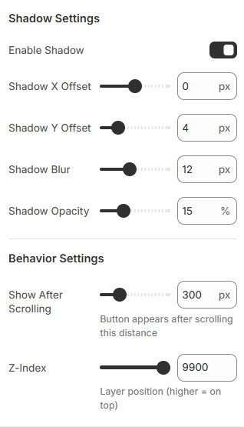

<section id="scroll-to-top">
<h2>Scroll to Top Button</h2>

<p>
This section lets you add a scroll-to-top button that appears as users scroll down the page.
You can customize its appearance, size, position, icon type, and hover effects.
</p>

<h3>Settings Overview:</h3>
<ul>
<li><b>Enable Button:</b> Toggle the scroll-to-top button on or off.</li>
<li><b>Button Appearance:</b> Set background color, hover color, icon color, size, and border radius.</li>
<li><b>Icon Settings:</b> Choose icon type (arrow, chevron, double arrow, caret, or text) and icon size.</li>
<li><b>Progress Border:</b> Customize progress indicator color, background, stroke width, and animation speed.</li>
<li><b>Position (Desktop & Mobile):</b> Set distance from bottom/right and adjust size for mobile devices.</li>
<li><b>Animation Effects:</b> Enable hover effects, adjust animation speed, and scale on show/hide and hover.</li>
<li><b>Scroll Behavior:</b> Choose smooth or instant scroll back to top.</li>
<li><b>Shadow Settings:</b> Add shadow with X/Y offset, blur, and opacity.</li>
<li><b>Behavior Settings:</b> Set scroll threshold for when the button appears and its z-index position.</li>
</ul>

<p>
This feature improves user navigation, making it easier for visitors to return to the top of the page.
Fully customizable options ensure it matches your store's style and branding.
</p>
</section>

